**Institute of Computer Technology**

**B. Tech Computer Science and Engineering**

**Name:** Prajapati Yash P.

**Batch:** BDA B-23

**Enrollment No.:** 20162121023

**Subject:** Computer Organization (2CSE205)

**Sem:** 2

**PRACTICAL-EXAM**

**AIM: - To design and perform ALU circuit**

1. **Arithmetic operation of 2 number having 4 bits**
2. **Logical operation of 2 number having 4 bits**

**Components: -**

* Full Adder
* AND, OR, XOR, NOT Gates
* Multiplexers

**Reference Table: -**

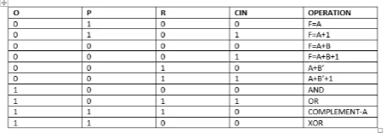

**Labwork: -**

1. **Arithmetic operation of 2 number having 4 bits**

***Answer:***

In given below circuit, if we keep **O input at zero (0)**, then it will do Arithmetic operations between two numbers.

If we keep value as follows: -

Data (assume): -

**A – 1010**

**B – 1110**

And if we want to perform **subtraction**, i.e. **A+B’+1**

Therefore, according to table, we will have to keep values as follows: -

**O = 0**

**P = 0**

**R = 1**

**Cin = 1**

**Expected Output: - 1100**

***OUTPUT*** 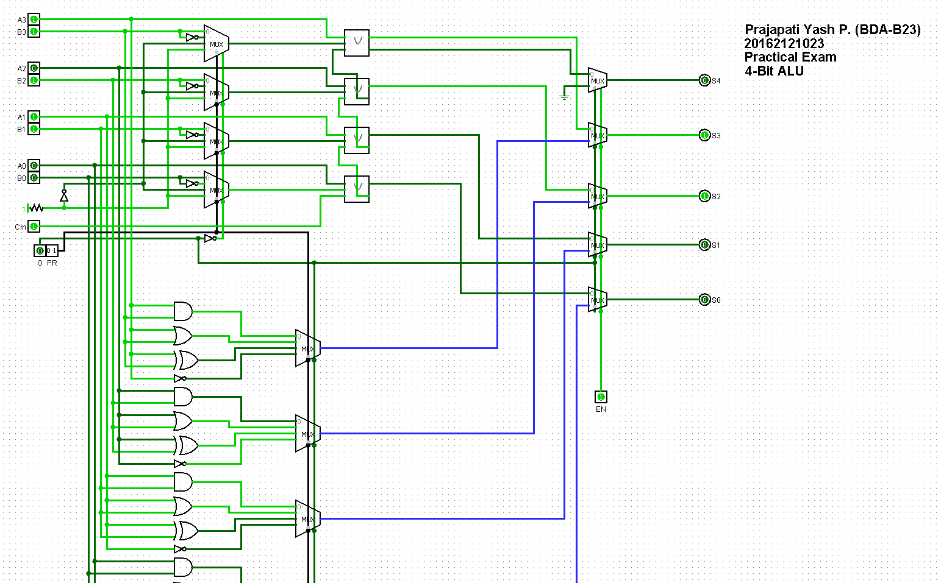

1. **Logical operation of 2 number having 4 bits**

***Answer:***

In given circuit, if we keep **O input at one (1)**, then it will do Logical operations between two numbers.

If we keep value as follows: -

Data (assume): -

**A – 1010**

**B – 1110**

And if we want to perform **AND operation.**

Therefore, according to table, we will have to keep values as follows: -

**O = 1**

**P = 0**

**R = 0**

**Cin = 0**

**Expected Output: - 1010**

***OUTPUT***

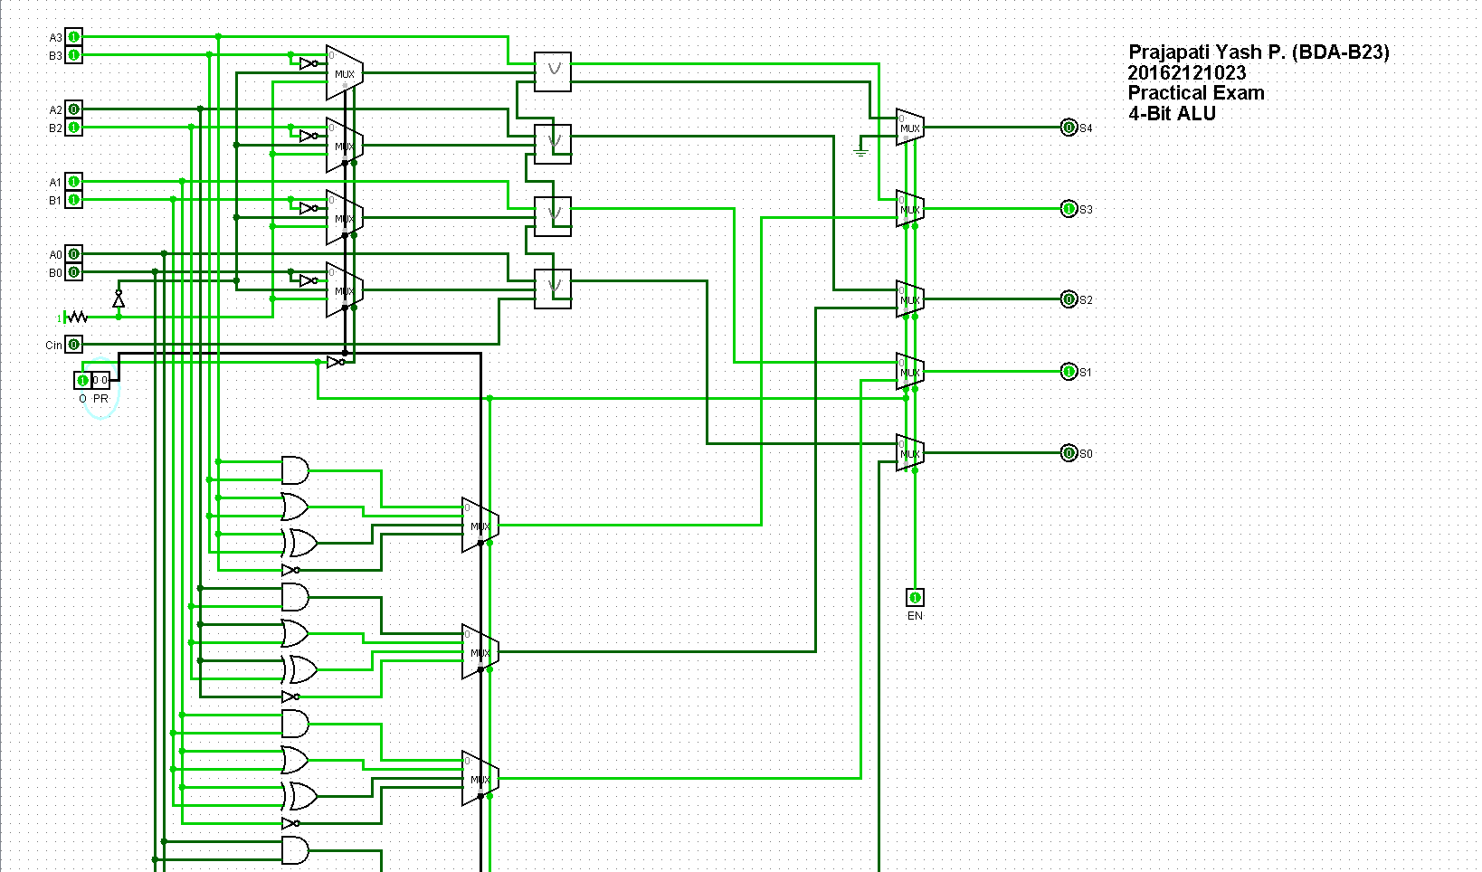

**Conclusion: -**

Hence, by studying and analysing the results of the following circuit, we conclude the design and working of the ALU circuit.